﻿﻿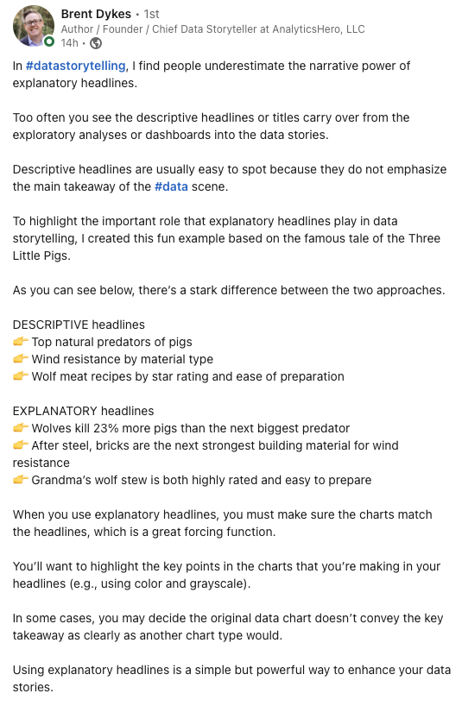

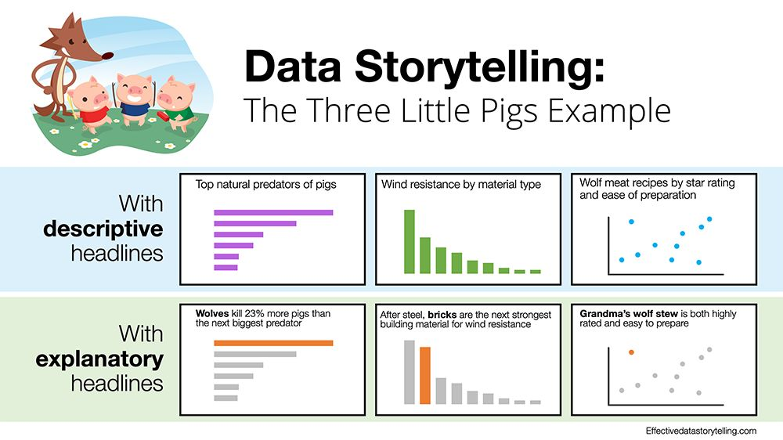  
﻿﻿

Full credit to Brent Dykes.

Here's the [link to the original post](https://www.linkedin.com/posts/brentdykes_datastorytelling-data-storytelllingwithdata-activity-7008888471440306176-kqSW?utm_source=share&utm_medium=member_desktop).

﻿﻿



  
﻿﻿

Full credit to Brent Dykes.

Here's the [link to the original post](https://www.linkedin.com/posts/brentdykes_datastorytelling-data-storytelllingwithdata-activity-7008888471440306176-kqSW?utm_source=share&utm_medium=member_desktop).